April 2023
https://www.cswe.org/accreditation/fellowship/
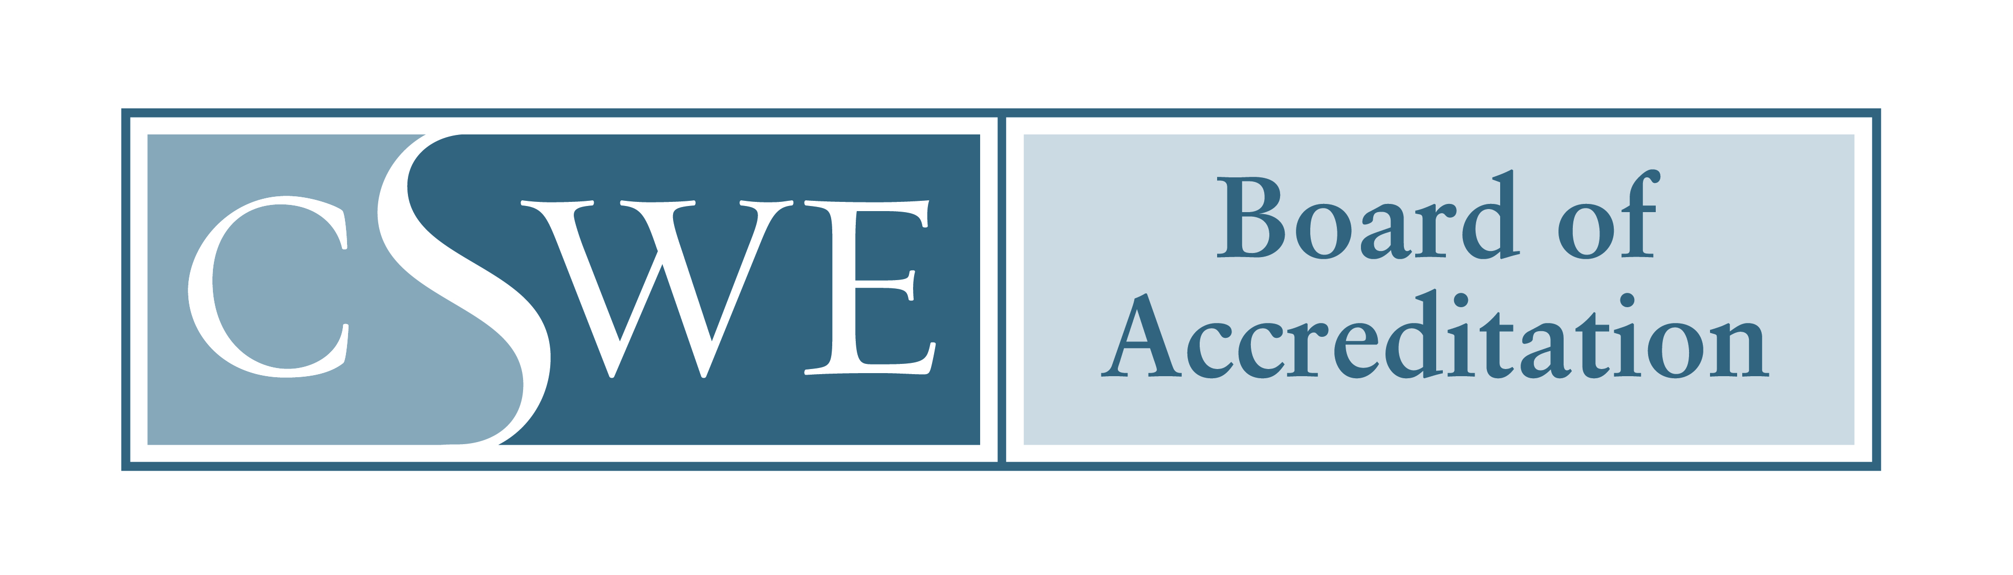
Post-master’s Fellowship AccREDITATION
Cohort Report

Introduction

Fellowship programs accredited by the Council on Social Work Education (CSWE)’s Board of Accreditation (BOA) provide training and supervision to master’s-level social work practitioners within one or more defined areas of social work practice. To maintain CSWE accreditation, accredited fellowship programs must complete a Cohort Report within 60 days of each cohort’s completion date.

The purpose of the Cohort Report is to obtain information on the recent cohort and program assessment activities. The report also includes verification of the program’s continued compliance with key accreditation requirements.

In accordance with the Post-master’s Social Work Fellowship Accreditation Handbook, if an accredited fellowship program fails to submit a Cohort Report on time, CSWE’s BOA may initiate an adverse action.

SUBMISSION INSTRUCTIONS

The Cohort Report must be completed in full and signed by the fellowship program director and department administrator (or fellowship program director’s superior).

The Cohort Report must be submitted as one (1) comprehensive electronic copy (either searchable PDF or Word document) to fellowshipaccred@cswe.org. Scanned documents, cloud documents, password-protected, or separate attachments will not be accepted. Further information regarding document formatting and submission requirements are specified in the “Document Submission Guidelines” section of the Post-Master’s Social Work Fellowship Accreditation Handbook.

Questions concerning the Cohort Report or maintaining accreditation may be directed to the Manager of Social Work Fellowship Accreditation at fellowshipaccred@cswe.org or (703) 519-2062.

COHORT Report

FELLOWSHIP PROGRAM INFORMATION
Name of Site Hosting Fellowship Program: Click here to enter text.
Fellowship Name: Click here to enter text.

FELLOWSHIP Program director information
Name: Click here to enter text. | Credentials: Click here to enter text. |  | Title: Click here to enter text.
Phone: Click here to enter text. |  | E-mail: Click here to enter text.

dEPARTMENT Administrator information (Person to whom the program director reports)
Name: Click here to enter text. | Credentials: Click here to enter text. |  | Title: Click here to enter text.
Phone: Click here to enter text. |  | E-mail: Click here to enter text.

COHORT INFORMATION
Recent Cohort:
- Identify when this cohort started the fellowship.
Click or tap to enter a date.

- Identify when this cohort completed the fellowship.
Click or tap to enter a date.

- Identify the total number of trainees that were enrolled in this cohort.
Click here to insert number.

- Identify the number of trainees in this cohort that successfully completed the program.
Click here to insert number.

If any trainees did not successfully complete the program, identify reason(s) here: Click here to enter text.

- List each facility used for the fellowship practice experience portion of the program for this cohort:
Click here to enter text.

If any changes to these facilities are anticipated for the next cohort, please describe here: Click here to enter text.

Recent Program Assessment Efforts:
- Briefly describe how the program assessed achievement of the program’s mission and goals in the past year (fellowship standard 4.1):
Click here to enter text.

- Briefly describe how the program has assessed curriculum effectiveness in the past year (fellowship standard 4.2):
Click here to enter text.

- Briefly describe how the program has assessed the effectiveness of the program’s learning environment for the recent, or previous, cohort (fellowship standard 4.3).
Click here to enter text.

- Briefly describe how the program has used program completion and post-completion preparedness of fellows to assess the effectiveness of the program over the past year (fellowship standard 4.4)
Click here to enter text.

- In accordance with standard 4, with a commitment to ongoing continuous program improvement, briefly describe any changes made to the program as a result of these assessment efforts.
Click here to enter text.

Next Cohort:
- In accordance with fellowship standard 3.1, with a commitment to anti-racism, diversity, equity and inclusion, describe how the program actively encouraged underrepresented groups to apply to the program:
Click here to enter text.

- Identify when the next cohort started or is expected to start.
Click or tap to enter a date.

- Identify when the next cohort is expected to complete the program.
Please note: The next Cohort Report will be due within 60 days of that cohort completing the program.
Click or tap to enter a date.

SUBSTANTIVE CHANGE REPORTING VERIFICATION
Place a checkmark next to any substantive changes made to the fellowship program since submission of the most recent Self-Study or Cohort Report
☐ | Change in fellowship program director
☐ | Change in ownership of host site
☐ | Change in fellowship programs’ mission
☐ | Change in fellowship programs’ defined area(s) of social work practice
☐ | Change to fellowship program’s format (full-time, part-time)
☐ | Increase in the number of trainee positions
☐ | Decrease in resources (financial, personnel, facilities, equipment)
Please identify when these changes were reported to CSWE:
Click here to enter text.

For any changes not previously reported, the fellowship program must submit to CSWE staff a detailed written description of the proposed change(s) and the potential impact on compliance with the Eligibility Requirements and/or Post-master’s Social Work Fellowship Accreditation Standards. As a reminder, per the Post-Master’s Social Work Fellowship Accreditation Handbook, CSWE must be informed in advance of major fellowship changes.

FELLOWSHIP PROGRAM ATTESTATIONS
Place a checkmark next to each disclosure acknowledging understanding and intent to comply.
☐ | The fellowship program provides complete and accurate information to CSWE.
☐ | The fellowship program publishes complete and accurate information about the program.
☐ | The fellowship program conducts all operations in an ethical manner.
☐ | The fellowship program agrees to remain in compliance with all accreditation requirements as outlined in the Post-Master’s Social Work Fellowship Accreditation Handbook, including updates and revisions made and communicated by CSWE.
☐ | The fellowship program understands that the fellowship program is solely responsible for implementing, demonstrating, and maintaining compliance with the Post-Master’s Social Work Fellowship Accreditation Standards.
☐ | The fellowship program agrees that CSWE may, at its discretion, share program information with other accrediting organizations and government entities.
☐ | The fellowship program understands that all accreditation fees are nonrefundable.
☐ | The fellowship program understands that CSWE may, in the reasonable exercise of its discretion, cease review or withdraw accreditation should the fellowship program violate the terms identified in the Post-Master’s Social Work Fellowship Accreditation Handbook.

SIGNATURES
By completing and signing this form, I acknowledge my fellowship program is committed to maintaining accreditation.
Fellowship Program Director Signature:  Click here to enter text. | Date: Click or tap to enter a date.
Department Administrator Signature (person to whom the program director reports):  Click here to enter text. | Date: Click or tap to enter a date.

