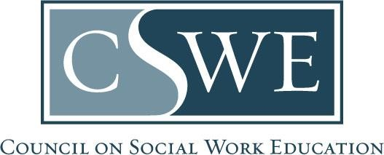

Commission on Accreditation (COA)
Department of Social Work Accreditation (DOSWA)
Baccalaureate and Master’s Social Work Program Accreditation

2022 EPAS
Form AS 4.4.1 | Budget Form

[Delete this help text before submission: Delete the directions before submission.]

Directions

Purpose
- Complete this form to identify the program’s financial resources per Accreditation Standard 4.4.1.
- A copy of this form is embedded in the required Volume 1 templates for Benchmark 1, Benchmark 2, and Reaffirmation / Initial Accreditation Self-study.

Formatting & Submission
- Submit this form within your accreditation documents, which may be submitted as a Microsoft Word document or searchable PDF, per policy 1.2.11. Document Submission Policy in the EPAS Handbook.
  - Accreditation documents must be a single document and may not include separate attachments nor appendices.
  - Scanned documents will not be accepted.
- Email completed accreditation documents to the program’s assigned Accreditation Specialist by the due date.

Timeframe for Review & Response
Accreditation documents are reviewed and processed at the assigned COA meeting. Programs and their institution’s president / chancellor will receive a decision letter 30-days after the conclusion of the COA meeting.

Program Level:
(check one only)
☐ Baccalaureate
☐ Master’s

Program Budget

Program Budget Expenses | Previous Year:  20YY-20YY | Current Year:  20YY-20YY | Next Year:  20YY-20YY
Full-time Faculty Salaries | $ | $ | $
Administrator Salaries | $ | $ | $
Part-time Faculty Salaries | $ | $ | $
Staff Salaries | $ | $ | $
Fringe Benefits  (for all faculty, administrators, & staff) | $ | $ | $
Student Financial Aid | $ | $ | $
Technological Resources | $ | $ | $
Supplies & Ancillary Services | $ | $ | $
Travel  (for all faculty, administrators, staff, & students) | $ | $ | $
Other, please specify | $ | $ | $
Total: | $ | $ | $

