2021 Annual Program Meeting Marketing Toolkit

This toolkit is intended to help attendees, presenters, exhibitors, and sponsors market their participation in the 2021 CSWE Annual Program Meeting. Use the following graphics and text to promote your booth, education session, or sponsorship at #APM2021!

Email Invitation Template
Presenters, invite your colleagues to attend your presentation using the following editable letter template.

Subject line: Attend my session on [topic] at CSWE’s 2021 Annual Program Meeting

Dear Colleagues,

Please join me at the 2021 CSWE Annual Program Meeting in Orlando, FL, where I’ll be delivering a presentation about [insert session name or topic] on November [insert session date] at [insert session time].

During my presentation, I plan to discuss [insert session takeaways and objectives, latest research, etc.]

I hope to see you there! To register, visit www.cswe.org/APM.

Email Signature Banner
Add a message and banner to your email signature to promote your participation at #APM2021! Hyperlink your banner to https://www.cswe.org/APM.

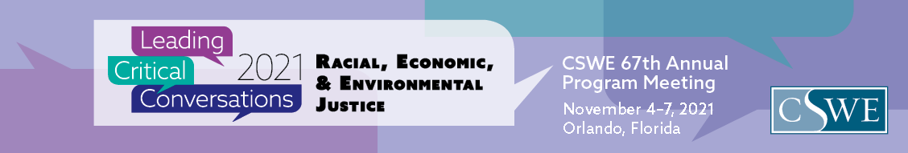

Attendee message:
I’ll be attending CSWE’s 2021 Annual Program Meeting in Orlando—see you there!

Speaker message:
I’ll be leading critical conversations at CSWE’s 2021 Annual Program Meeting in Orlando. Join my session, [insert session name], on November [insert session date] at [insert session time].
Exhibitor message:
Are you headed to #APM2021? Swing by Booth #[insert booth number] in the exhibit hall to learn more about [insert program/company name or offerings] and [insert information about potential giveaways, prizes, or other activities available at the booth].

Sponsor message:
[program or company name] is a proud supporter of CSWE’s 2021 Annual Program Meeting.

Sample Social Media Posts
The following social posts can be customized and shared over your social channels. Use the shareable graphics below to accompany your post.

Attendee
I’m looking forward to connecting with new and old friends at #APM2021! Shoot me a note if you’ll be in Orlando so we can meet face-to-face.

Speaker
I’ll be leading critical conversations at #APM2021 in Orlando! Attend my presentation on [insert session date] to gain a better understanding of [insert session topic].

Join my session at #APM2021! My presentation on November [insert session date] will cover [insert session topic or objectives and how it relates to social work educators].

Exhibitor
[insert program or company name] is proud to exhibit at CSWE’s 2021 Annual Program Meeting. Visit us at Booth #[insert booth number] in the exhibit hall to learn more about [insert program or company offerings] and enter to win [insert raffle/giveaway prize].

#APM2021 is in just [insert #] days! Stop by Booth #[insert booth number] to [insert information about activities available at booth (e.g., open positions or raffles/giveaways/prizes)].

Sponsor
[insert program or company name] is proud to sponsor [insert sponsorship (e.g., Carl A. Scott Memorial Lecture, technology giveaway)] at CSWE’s 2021 Annual Program Meeting!

[insert program or company name] is honored to be a [insert tier if applicable (e.g., Premier, Platinum, Gold, Silver, Bronze)] sponsor of CSWE’s 67th Annual Program Meeting. See you in Orlando for #APM2021!

Hashtags
#APM2021

Links
CSWE Twitter: https://twitter.com/CSocialWorkEd
CSWE Facebook: https://www.facebook.com/CSocialWorkEd/
CSWE LinkedIn: https://www.linkedin.com/company/council-on-social-work-education
CSWE APM website: https://cswe.org/apm

Shareable Graphics
