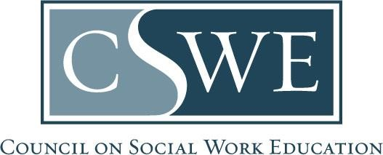

Commission on Accreditation (COA)
Department of Social Work Accreditation (DOSWA)
Baccalaureate and Master’s Social Work Program Accreditation

2022 EPAS
Form AS 4.4.3 | Library Report

[Delete this help text before submission: Delete the directions before submission.]

Directions

Purpose
- Complete this form to identify the program’s library resources per Accreditation Standard 4.4.3.
- A copy of this form is embedded in the required Volume 1 templates for Benchmark 1, Benchmark 2, and Reaffirmation / Initial Accreditation Self-study.

Formatting & Submission
- Submit this form within your accreditation documents, which may be submitted as a Microsoft Word document or searchable PDF, per policy 1.2.11. Document Submission Policy in the EPAS Handbook.
  - Accreditation documents must be a single document and may not include separate attachments nor appendices.
  - Scanned documents will not be accepted.
- Email completed accreditation documents to the program’s assigned Accreditation Specialist by the due date.

Timeframe for Review & Response
Accreditation documents are reviewed and processed at the assigned COA meeting. Programs and their institution’s president / chancellor will receive a decision letter 30-days after the conclusion of the COA meeting.

Library Resources for the Social Work Program

- Describe whether there is a library specific to the social work program, a single institutional library, and/or multiple intuitional libraries available to social work students, faculty, and staff.

Insert text here

- Describe the availability of library resources for social work students, faculty, and staff (e.g., hours, virtual access, in-person access).

Insert text here

- Describe library equipment and technology available to social work students, faculty, and staff (e.g., computers, scanners, printers).

Insert text here

- Describe social work student, faculty, and staff access to online resources (e.g., databases, catalogs, subject guides, academic journals).

Insert text here

- Describe social work student access to consortium library resources (e.g., interlibrary library loan, article delivery, and other related services).

Insert text here

- Describe how social work faculty, staff, and/or students can recommend library items for purchase, and describe how the library addresses such recommendations.

Insert text here

- Describe the borrowing/access policies relevant the social work students, faculty, and staff, including costs, limitations on access/delivery, and/or restrictions.

Insert text here
- Describe any resources available exclusively to social work students, if any.
Insert text here

Library Faculty / Staff

- Describe the availability of a librarian with a specific social work designation (e.g., social work librarian, social work bibliographer, and/or social work liaison). If so, describe the job responsibilities and the relevant activities of this position.
Insert text here

- Describe any other librarian roles/activities at the library that benefit social work education, such as data management or scholarly support.

Insert text here

Instructional Supports and Services

- Describe the instructional supports offered for social work faculty, such as subject and course guides, tutorials, and videos.

Insert text here
- Describe how reference and consultation services are offered for social work students, faculty, and staff (e.g., videoconferencing, telephone, and/or email).

Insert text here
- Describe the options offered for course-integrated library instruction for social work courses, both in-person and online (synchronous and asynchronous).

Insert text here

